Final Year B. Tech., Sem VII 2024-25

High Performance Computing Lab
Practical No. 9

Implement Matrix-Vector Multiplication using MPI. Use different number of processes and analyze the performance.
→
Code →
#include <mpi.h>
#include <stdio.h>
#include <stdlib.h>

#define MATRIX_SIZE 700

int main(int argc, char *argv[]) {
int rank, size, i, j;
double matrix[MATRIX_SIZE][MATRIX_SIZE];
double vector[MATRIX_SIZE];
double local_result[MATRIX_SIZE], result[MATRIX_SIZE];
double start_time, end_time;

MPI_Init(&argc, &argv);
MPI_Comm_rank(MPI_COMM_WORLD, &rank);
MPI_Comm_size(MPI_COMM_WORLD, &size);

int rows_per_process = MATRIX_SIZE / size;

if (rank == 0) {

for (i = 0; i < MATRIX_SIZE; i++) {
vector[i] = 1;
for (j = 0; j < MATRIX_SIZE; j++) {
matrix[i][j] = i + j;
}
}
}

double local_matrix[rows_per_process][MATRIX_SIZE];
MPI_Scatter(matrix, rows_per_process * MATRIX_SIZE, MPI_DOUBLE,
local_matrix, rows_per_process * MATRIX_SIZE, MPI_DOUBLE,
0, MPI_COMM_WORLD);

MPI_Bcast(vector, MATRIX_SIZE, MPI_DOUBLE, 0, MPI_COMM_WORLD);

start_time = MPI_Wtime();

for (i = 0; i < rows_per_process; i++) {
local_result[i] = 0.0;
for (j = 0; j < MATRIX_SIZE; j++) {
local_result[i] += local_matrix[i][j] * vector[j];
}
}

MPI_Gather(local_result, rows_per_process, MPI_DOUBLE,
result, rows_per_process, MPI_DOUBLE,
0, MPI_COMM_WORLD);

end_time = MPI_Wtime();

if (rank == 0) {
printf("Resultant vector:\n");
// for (i = 0; i < MATRIX_SIZE; i++)
// printf("%f ", result[i]);
printf("%f ", result);
printf("\n");

printf("Time taken: %f seconds\n", end_time - start_time);
}

MPI_Finalize();
return 0;
}

Output →

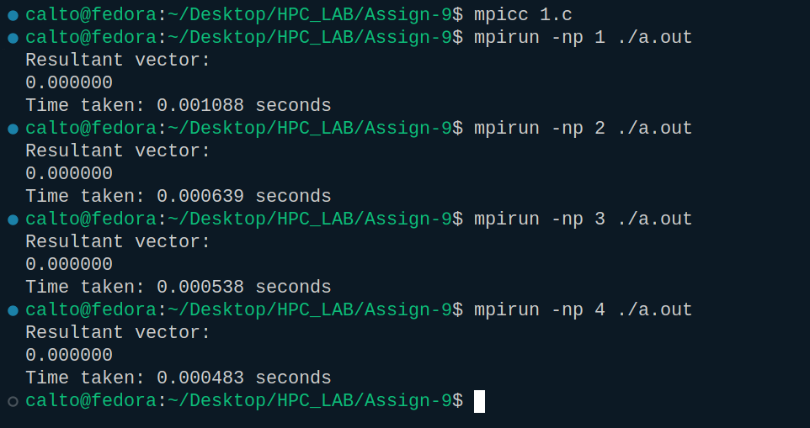

Implement Matrix-Matrix Multiplication using MPI. Use different number of processes and analyze the performance.
→
Code →
#include <mpi.h>
#include <stdio.h>
#include <stdlib.h>

#define MATRIX_SIZE 200
int main(int argc, char *argv[]) {
int rank, size, i, j, k;
double A[MATRIX_SIZE][MATRIX_SIZE], B[MATRIX_SIZE][MATRIX_SIZE], C[MATRIX_SIZE][MATRIX_SIZE];
double local_A[MATRIX_SIZE][MATRIX_SIZE], local_C[MATRIX_SIZE][MATRIX_SIZE];
double start_time, end_time;
MPI_Init(&argc, &argv);
MPI_Comm_rank(MPI_COMM_WORLD, &rank);
MPI_Comm_size(MPI_COMM_WORLD, &size);
int rows_per_process = MATRIX_SIZE / size;

if (rank == 0) {
for (i = 0; i < MATRIX_SIZE; i++) {
for (j = 0; j < MATRIX_SIZE; j++) {
A[i][j] = i + j;
B[i][j] = i * j;
}
}
}
MPI_Bcast(B, MATRIX_SIZE * MATRIX_SIZE, MPI_DOUBLE, 0, MPI_COMM_WORLD);
MPI_Scatter(A, rows_per_process * MATRIX_SIZE, MPI_DOUBLE,
local_A, rows_per_process * MATRIX_SIZE, MPI_DOUBLE,
0, MPI_COMM_WORLD);
start_time = MPI_Wtime();

for (i = 0; i < rows_per_process; i++) {
for (j = 0; j < MATRIX_SIZE; j++) {
local_C[i][j] = 0.0;
}
}

for (i = 0; i < rows_per_process; i++) {
for (j = 0; j < MATRIX_SIZE; j++) {
for (k = 0; k < MATRIX_SIZE; k++) {
local_C[i][j] += local_A[i][k] * B[k][j];
}
}
}

MPI_Gather(local_C, rows_per_process * MATRIX_SIZE, MPI_DOUBLE,
C, rows_per_process * MATRIX_SIZE, MPI_DOUBLE,
0, MPI_COMM_WORLD);
end_time = MPI_Wtime();

if (rank == 0) {
printf("Resultant matrix C:\n");
// for (i = 0; i < MATRIX_SIZE; i++) {
// for (j = 0; j < MATRIX_SIZE; j++) {
// printf("%f ", C[i][j]);
// }
// printf("\n");
// }
printf("%f ", C);

printf("Time taken: %f seconds\n", end_time - start_time);
}

MPI_Finalize();
return 0;
}

Output →

